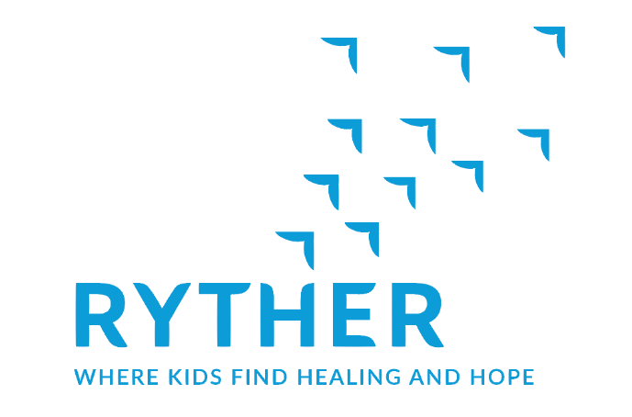

Volunteer Application
Please print clearly and be sure to fill out both sides. Attach a current resume, if you have one.

Today’s Date:

Full Name: Date of Birth:
(First) (Middle) (Last)

Address: City/State/Zip:

Phone: Work Cell Home Email:

Employer/School: Occupation/Field of Study:

Emergency Contact: Emergency Contact’s Phone(s):

Availability ~ Mark each box with a Yes or No.

 | Sun. | Mon. | Tues. | Wed. | Thu. | Fri. | Sat. | Comments:
Morning
Afternoon
Evening

Please list any previous volunteer experience. Include the organization, job title and dates.

How did you hear about Ryther? Why are you interested in volunteering here?

What Ryther programs or volunteer opportunities interest you?

Do you speak, read or write any languages other than English?

List any skills or interests you could share as a volunteer.

Do you have any physical, mental or emotional limitations? Please explain.

What age group are you interested in working with?

□ 6-8 years old □ 9-11 years old □ 12-14 years old □ Any

Personal or Professional References

Name | Title and Company | Phone Number | Email Address

Statement of Authorization

The statements set forth in this application are, to the best of my knowledge, true and complete. I agree that any misstatements or omissions as to material fact will constitute grounds for unfavorable consideration or dismissal from volunteering at Ryther. I hereby authorize Ryther to verify any of the information I have provided on this application. This verification may include former employers, educational and training institutions and other appropriate sources. I also agree to hold Ryther and those persons who are contacted in conjunction with my application harmless from any legal claim regarding compliance with the request herein. I agree to conform to Ryther volunteer policies as made known to me.

(Signature) (Date)

Thank you for thinking of Ryther. Please return this application to the Volunteer Coordinator scanned to volunteer@ryther.org or faxed/sent to the following address. Depending upon our volunteer needs, we’ll contact you for an interview or more information.

Ryther
c/o Volunteer Coordinator
2400 NE 95th Street
Seattle, WA 98115

(206) 517-0286
Fax: (206) 525-9795

VOLUNTEER/VISITOR CONFIDENTIALITY AGREEMENT
Development Department

I/We _____________________________________________ understand that as a visitor/visitors to Ryther and/or in performance of my/our duty/duties, I/we must hold any and all client-identifying information in strict confidence. I/We understand that any violation of the confidentiality of this information is in violation of state and federal rules of confidentiality. (RCW 70.02; RCW 71.05; RCW 71.34; 42 CFR, Part 2; 45 CFR, Parts 160 &164)

I/We understand that unauthorized disclosure of confidential client information is:

- a federal offence punishable by up to $500 for a first offense and up to $5,000 for any subsequent offense (42 CFR, Part 2);

- subject to state legal action resulting in $1,000 or 3 times the amount of actual damages, whichever is greater (RCW 71.05.440).

___________________________________________
Printed name(s)

___________________________________________ ____/____/______
Signature Date

(________) -________ -_____________ ___________________________________________
Phone Email Address

_________________________________________________________________________________________
Organization & Title (if applicable)

_________________________________________________________________________________________
Street City State Zip

Ryther
Disclosure of Criminal History

Ryther serves children and youth who have been emotionally, physically and/or sexually abused; have significant sexual behavior problems; have chemical abuse or dependency problems; and/or are undergoing major life crisis and transitions. For this reason, Ryther takes reasonable efforts to ensure the health, safety and welfare of our clientele. State law identifies criminal convictions that impact an individual’s ability to be employed, volunteer, or be an intern/trainee at Ryther and have access to children and youth. For this reason, your cooperation in completing this form as part of the volunteer process is appreciated and essential.

- Have you ever been found to have sexually abused, physically abused, neglected, abandoned or exploited a child or adult? □ No □ Yes

- Occurring within your lifetime, please list ALL:
- Pending charges
- Convictions
- Charges for which you offered a guilty plea, pleas of nolo contendere, or other pleas that did not contest the charges
- Circumstances where the underlying charge(s) were dismissed after a sentence was imposed and the conditions satisfied.
- Expunged records may appear in an applicant’s background check

□ No charges or convictions ever in my lifetime.

□ Yes, listed below with details:

CHARGES/CONVICTIONS  Include dates and location | DISPOSITION

The information set forth here is true and complete. I agree that any misstatements or omissions as to material fact might constitute grounds for unfavorable consideration or dismissal from volunteering at Ryther.

____________________________________ ____________________________________
Volunteer Printed Name Volunteer Signature

_________________
Date

